You are unique, your home is unique, and your family, location and situation are unique. My wish is for you to achieve as much joy as possible from your home and to give you the tools you need to make that happen, so that you can live happily ever after.

My aim is to give you all I have to ensure that you achieve your dream space and to achieve the goal you have set for yourself. Thank you for trusting me with your most sacred space and I can’t wait to meet with you and start this wonderful journey together.

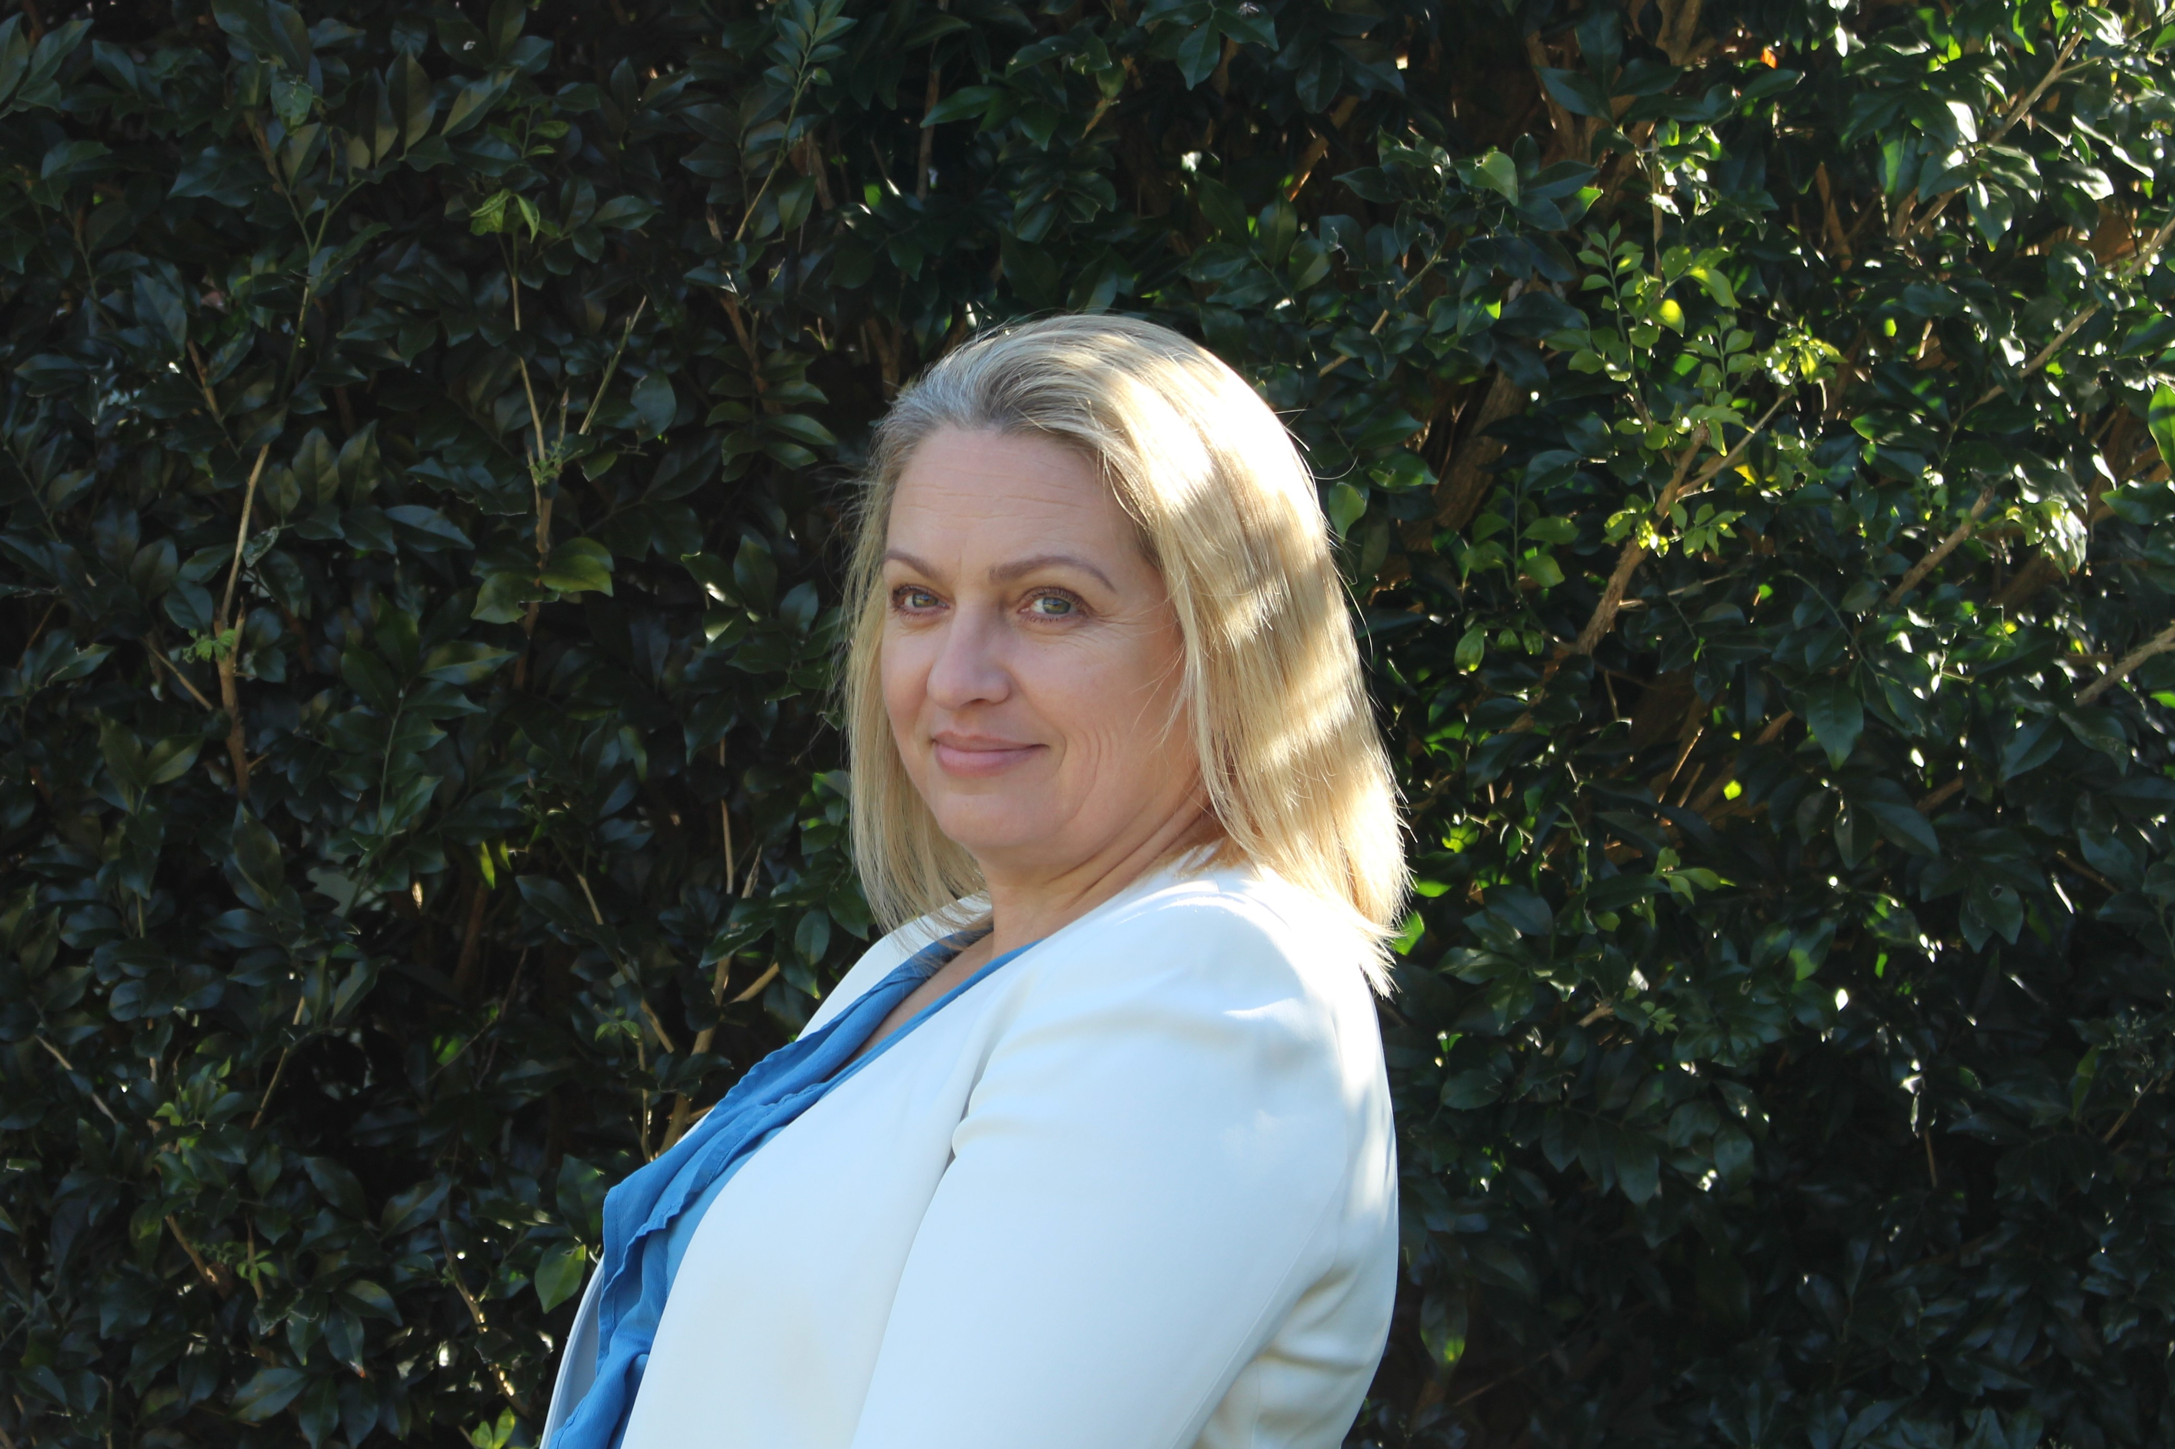

*“Its not houses that I love, it’s the life I live in them”.* ***Coco Chanel***

In order to gain the most out of our time together, please fill out this form and return it to me at least 24 hours before our session starts. You will get the best results for your project and the most out of our time together if you really take the time to complete this questionnaire to the best of your ability.

There are 18 questions.

**1. Who is this project for and who will be living in the property? Please include the name of all family members including any pets.**

*Please use this space to write your answer.*

**2. What is the property address? Please provide your contact details including a home or mobile number and skype or facetime details.**

*Please use this space to write your answer.*

**3. In your own words, tell me what you would like to achieve during our time together?**

*Please use this space to write your answer.*

**4.** **What do you expect to receive from me in terms of service, time and communication?** (*I ask this question to know your expectations, as this is different for everyone, I want to ensure there is no miscommunication*).

*Please use this space to write your answer.*

**5. Is your intention to sell the property or to keep the property once the work is completed?** (*Please explain*)

*Please use this space to write your answer.*

**6. What is the main area of your home would you like help with? Please be as specific as possible and tell me the main problem and then also the main goal.**

*Please use this space to write your answer.*

**7. Describe, the current spaces you have in the home. How do they make you feel right now? What is missing in them?**

*Please use this space to write your answer.*

**8. Search on the Internet or in magazines for images of the style of space that inspires you (don’t think about budget right now). Just get inspired, what wonderful things could you include if you had an unlimited budget, and what would make this home perfect? Paste your ideas below or share your Pinterest / Houzz board with me by pasting the link below or send me a screen shot, pdf or image in a separate email.**

*Please use this space to paste images.*

**9. Looking at the images you chose, please list 5-10 words that describe why you love the spaces or how they made you feel. (Try to use as many descriptive words as possible).**

*Please use this space to write your answer.*

**10. What is your budget?** *(You do not have to disclose this information if you don’t want to, although a rough estimate helps understand if your goals are realistic and helps me see the potential areas where we can balance your budget to ensure you get everything you want!)*

*Please use this space to write your answer.*

**11. Does your budget include furniture, soft furnishings and decoration? Please give an estimate of how much you intend to spend on this element of the design?** *(Its ok if you don’t know the answer, give your best guess)*

*Please use this space to write your answer.*

**12. What is a a) realistic timeline and b) hopeful timeline you would like to achieve the completed project by?**

*Please use this space to write your answer.*

**13. If you have bought the property recently, please provide the link or email me the link to the Real Estate agents sales brochure for the property. Please include any existing plans, photos and drawings that you have that are relevant. Please include any architectural surveys, drawings of plans you have of the property.**

*Please use this space to write your answer.*

**14. Do you prefer to use metric or imperial units?**

*Please use this space to write your answer.*

**15. Make your best guess of how you would like to position the furniture (for the main areas) you have or hope to have in the best way. (Don’t worry about being perfect here, just do your best!) You can describe this in words, draw a sketch or post an image of something similar that you think will work.**

*Please use this space to write your answer.*

**16. What is the scope of work you are prepared for? Are you willing to do a complete overhaul of the room / house or do you just want to repaint with a new colour and rearrange your existing furniture? Are you a DIY kind of person or will you get a builder or some kind of other help?**

*Please use this space to write your answer.*

**17. Are there any access issues to the property?**

*Please use this space to write your answer.*

**18. List your questions for me here. If you have planning, technical and structural questions, please list them here now, so that I am given a chance to provide you with a correct answer before we meet for our session.**

*Please use this space to write your answer.*

-------------------------------------------------------------------------------------------------------

**Step 1:**  Please email me your completed file to [monika@mkginteriors.com.au](mailto:monika@mkginteriors.com.au) at least 24 hours before our scheduled session. Please also include a signed copy of the terms and conditions. Without this we won’t be able to continue. (Please sign and email the last page or give it to me in person). Please note that up front payment will be required before our session.

**Step 2:** Please book in a time with me. (email [monika@mkginteriors.com.au](mailto:monika@mkginteriors.com.au) or phone 0411 273 864).

*-------------------------------------------------------------------------------------------------------*

I love reading about you and your project and in order to give you the best of me, I’d love for you to respect my time by ensuring you are punctual to our session (you are able to reschedule with me only once, so please take this session seriously). Please come prepared for our session together and ensure all family members are present. Here is what to expect:

During our session together, I will take you through the design steps that I have learned in almost 20 years in the architecture & interior design industry. We will explore your goals for the space and understand your personality, needs, expectations and your desired result. I hold current Public Liability and Professional Indemnity Insurance and am happy to pass on any details on request. If you have any questions regarding my qualifications and expertise, please get in touch.

My clients usually have a strong idea of what they want, and I help them achieve their desired outcome, so you don’t have to worry about me leading you down a scary path that isn’t your vision at all. I am looking forward to working with you!

Monika K Giannini



MKG Interior Design

PO Box 9445

Wyoming NSW 2250

Ph | 0411 273 864

Email | [monika@mkginteriors.com.au](mailto:monika@mkginteriors.com.au)

Web | mkginteriordesign.com